
Story

Date | 24 September 2024
Team ID | PNT2022TMIDxxxxxx
Project Name | EV Market Analysis (Tableau)
Maximum Marks | 5 Marks

By using stories in Tableau, you can effectively communicate complex data in a way that is both interactive and engaging, making it easier for the audience to follow along and understand the insights. It’s a tool for data storytelling, allowing you to present insights in a cohesive, engaging way that takes viewers through a logical progression of findings or analyses.
In Tableau, Story is a feature that allows you to create a sequence of dashboards, visualizations, and text to present data insights in a cohesive and narrative-driven way. It's like a slideshow within Tableau that guides the audience through a series of data points, helping them understand key insights, trends, or outcomes of your analysis.

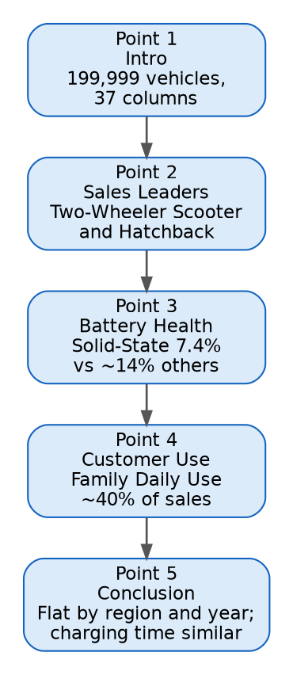

Story Points:
Point 1, Introduction: We analysed 199,999 EV records with 37 columns. Each point below builds one part of the story.
Point 2, Sales Leaders: Two-Wheeler Scooter and Hatchback lead unit sales. The top 10 manufacturers each sell between 8.7 and 9.5 million units.
Point 3, Battery Health: Solid-State batteries degrade least over 5 years (7.4% on average), compared with about 14% for NMC, NCA and Sodium-Ion.
Point 4, Customer Use: Family Daily Use accounts for about 40% of sales, followed by Urban Commute at about 27%.
Point 5, Conclusion: Regions, model years and customer ratings are almost flat, and fast charging does not cut charging time in this data. Product and battery decisions should focus on category and battery type.

Activity 2:
Publish Story on Tableau Public and paste the public link below:
[Paste your Tableau Public story link here]

